**Practical No. 15**

**Develop a simple application to –**

**Enter data into database Retrieve and present data from database.**

**COMMANDS ON COMMAND PROMPT:  
  
DATABASE RELATED COMMANDS:**

**CODE & OUTPUT AFTER RUNNING ON CMD :**

**SHOWING DATABASE:**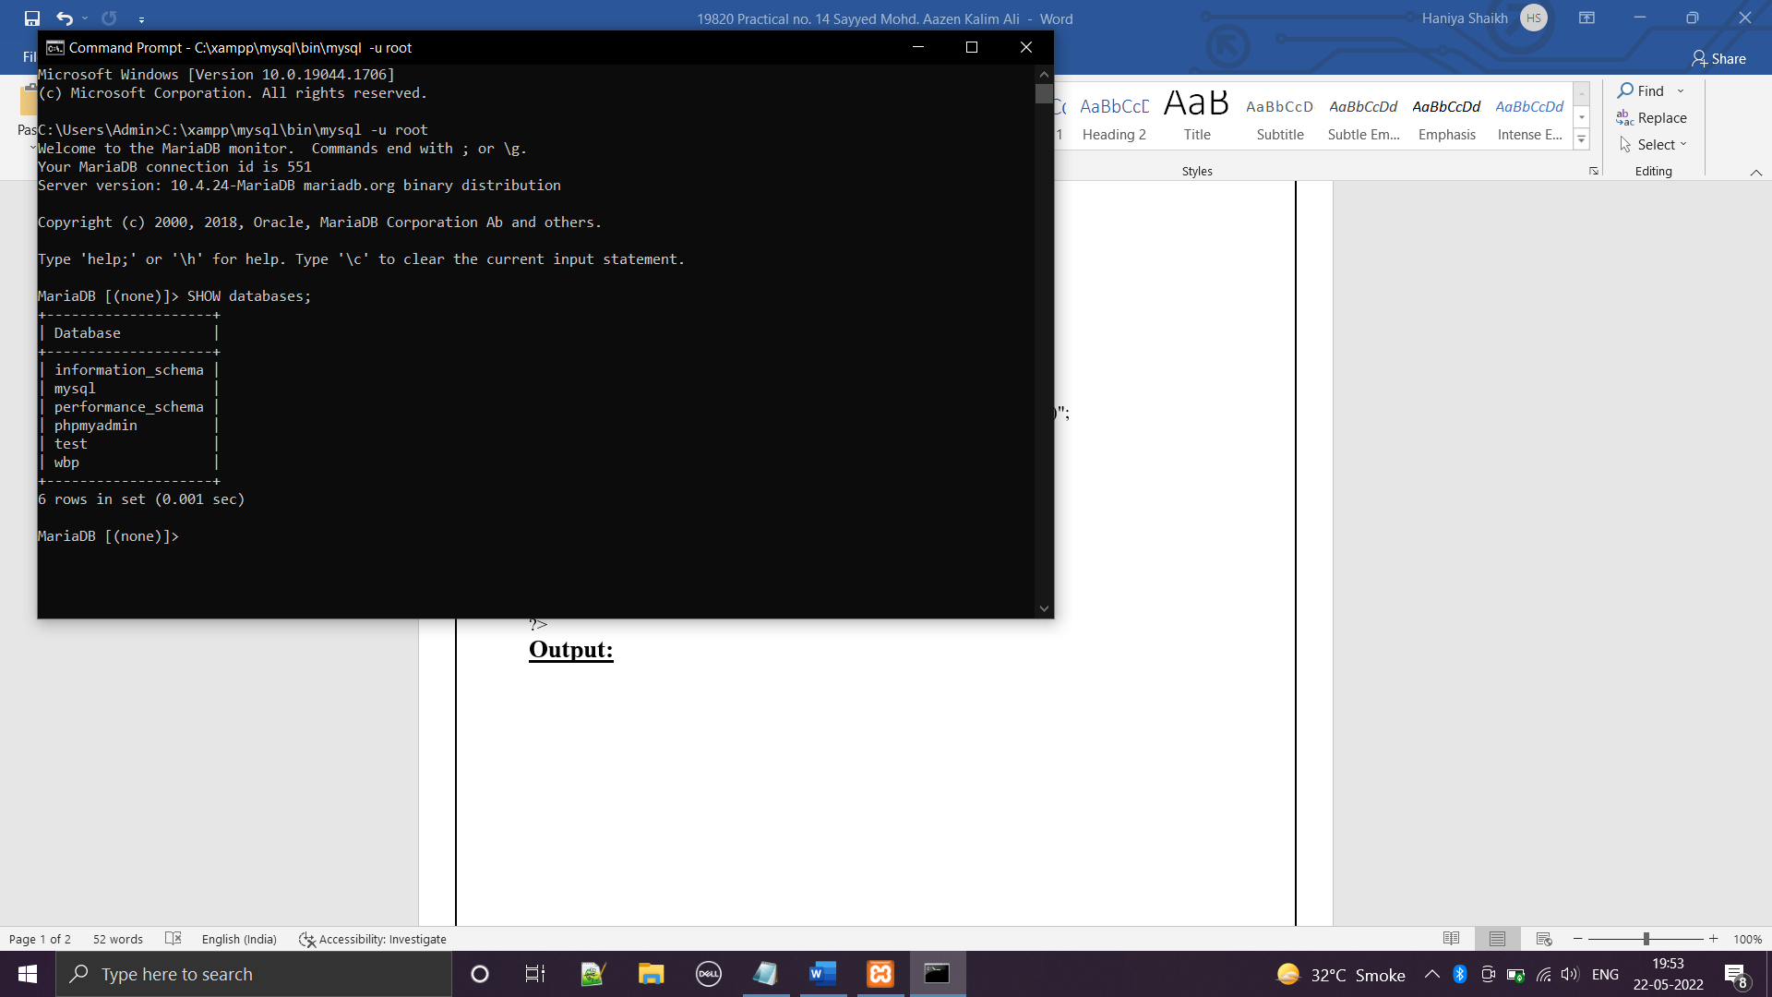

**DATABASE BEFORE CREATING STUDENT TABLE :**

**DATABASE AFTER CREATING STUDENT TABLE :**

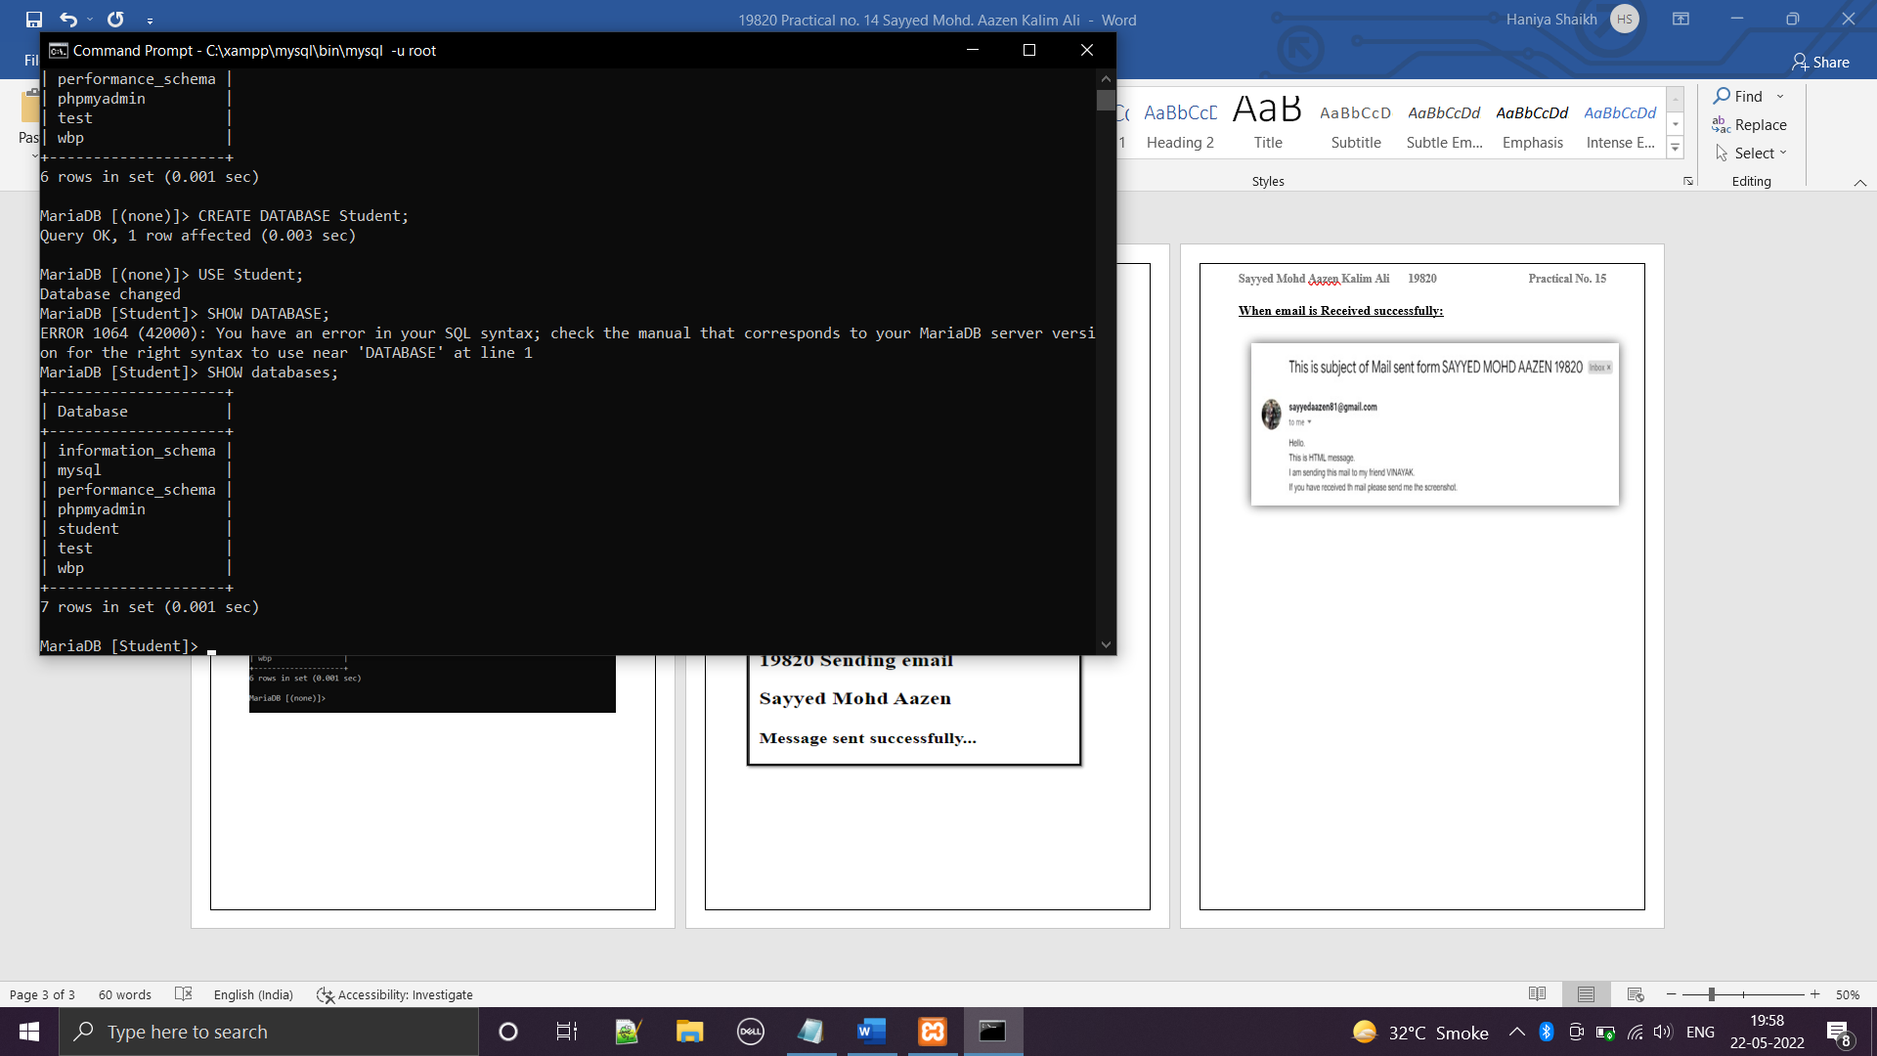

**SELECTING DATABASE:**

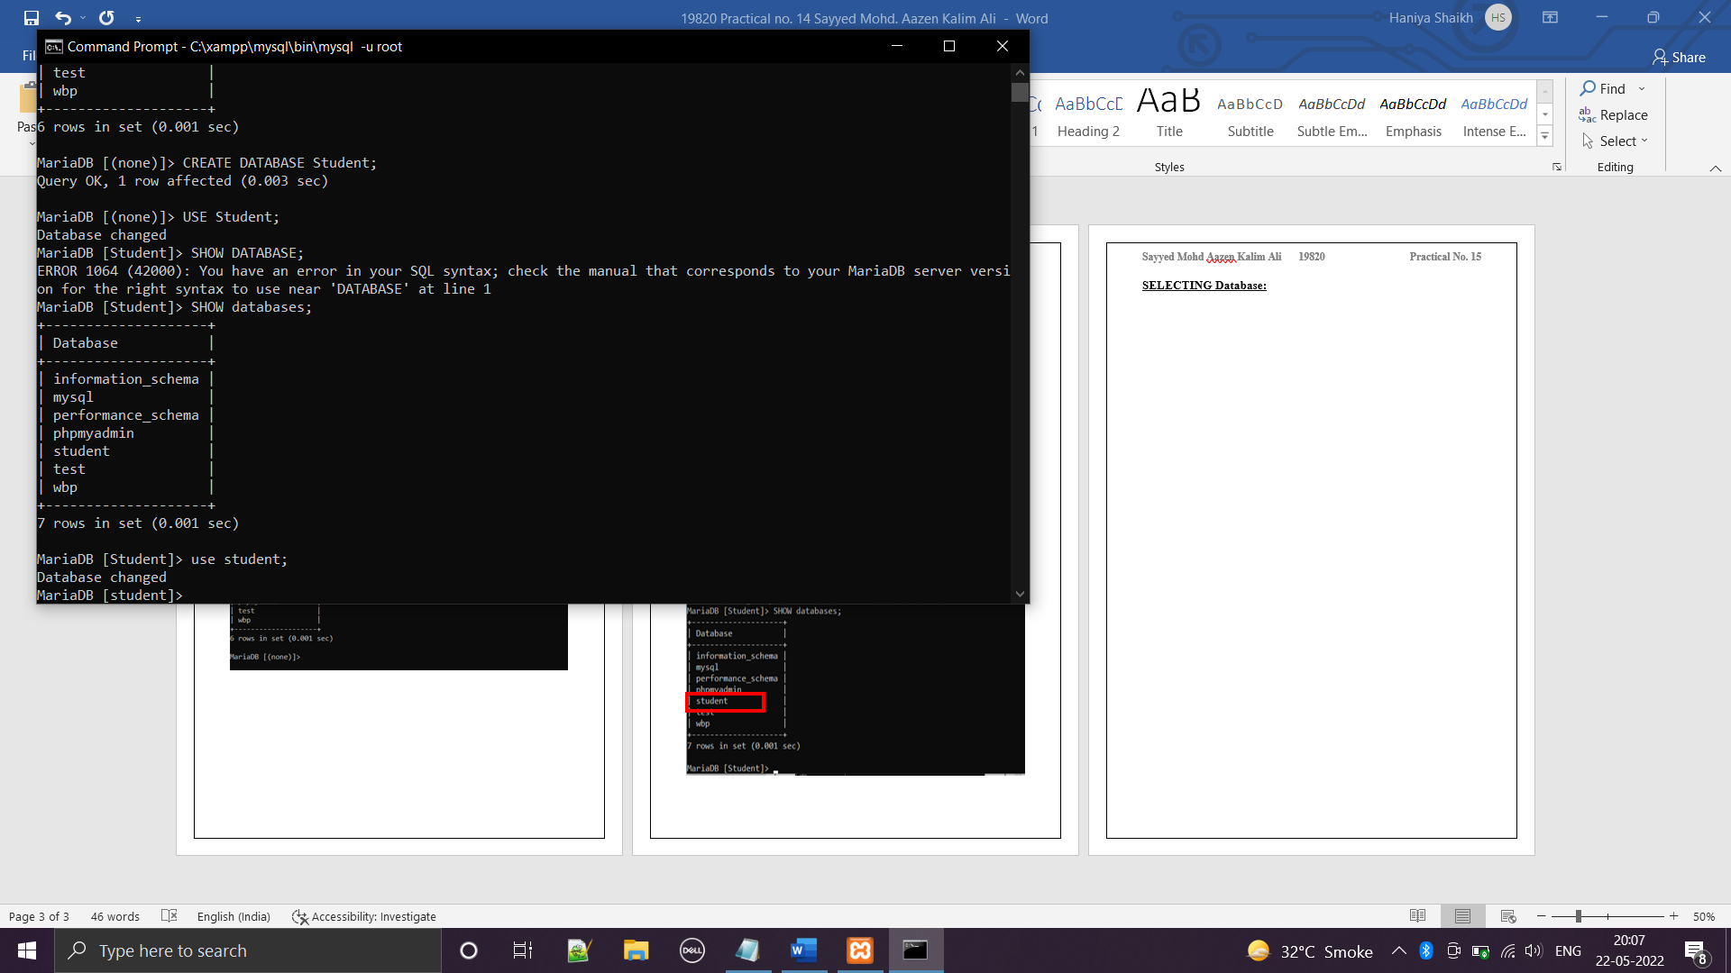

**DROPPING DATABASE:**

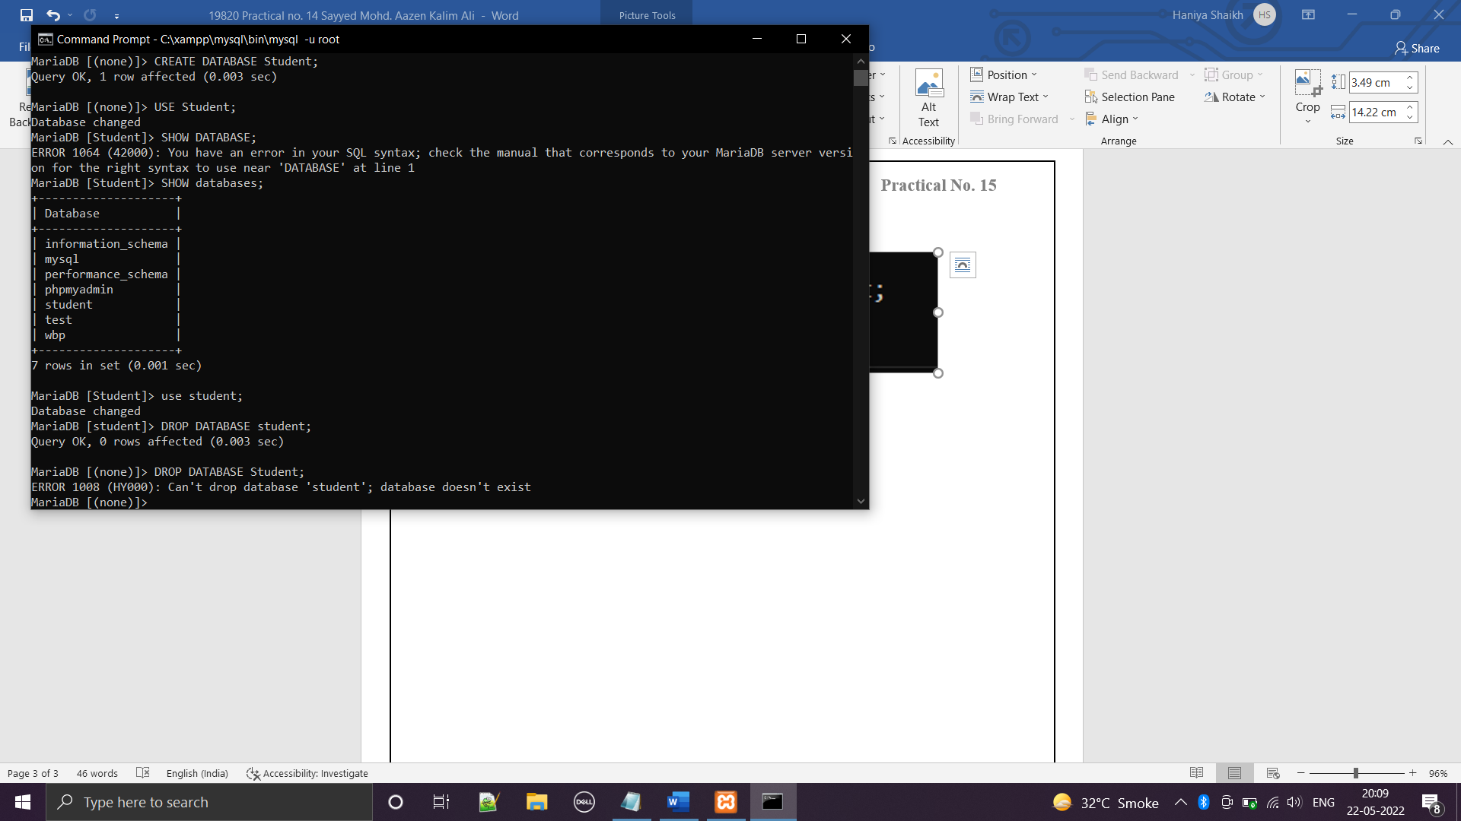 **CREATING TABLE IN DATABASE:**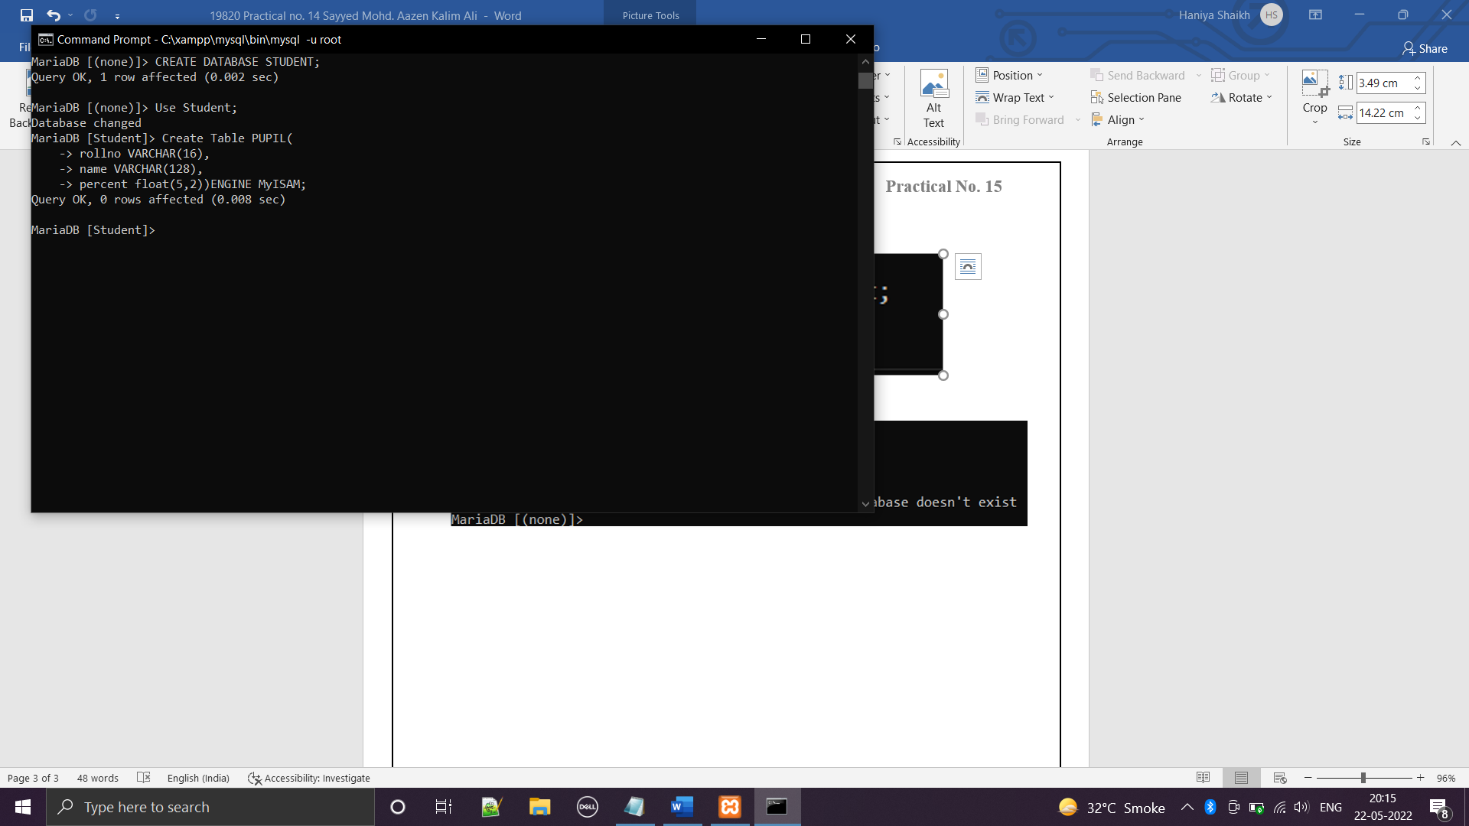

**DESCRIBING TABLE :**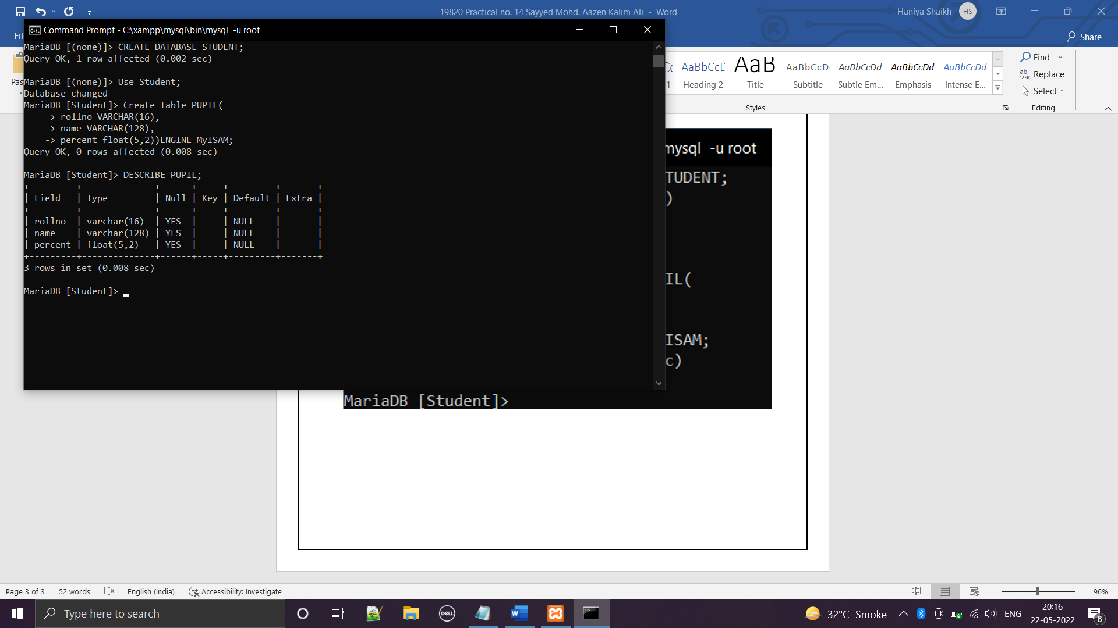

**ADDING DATA INTO TABLE: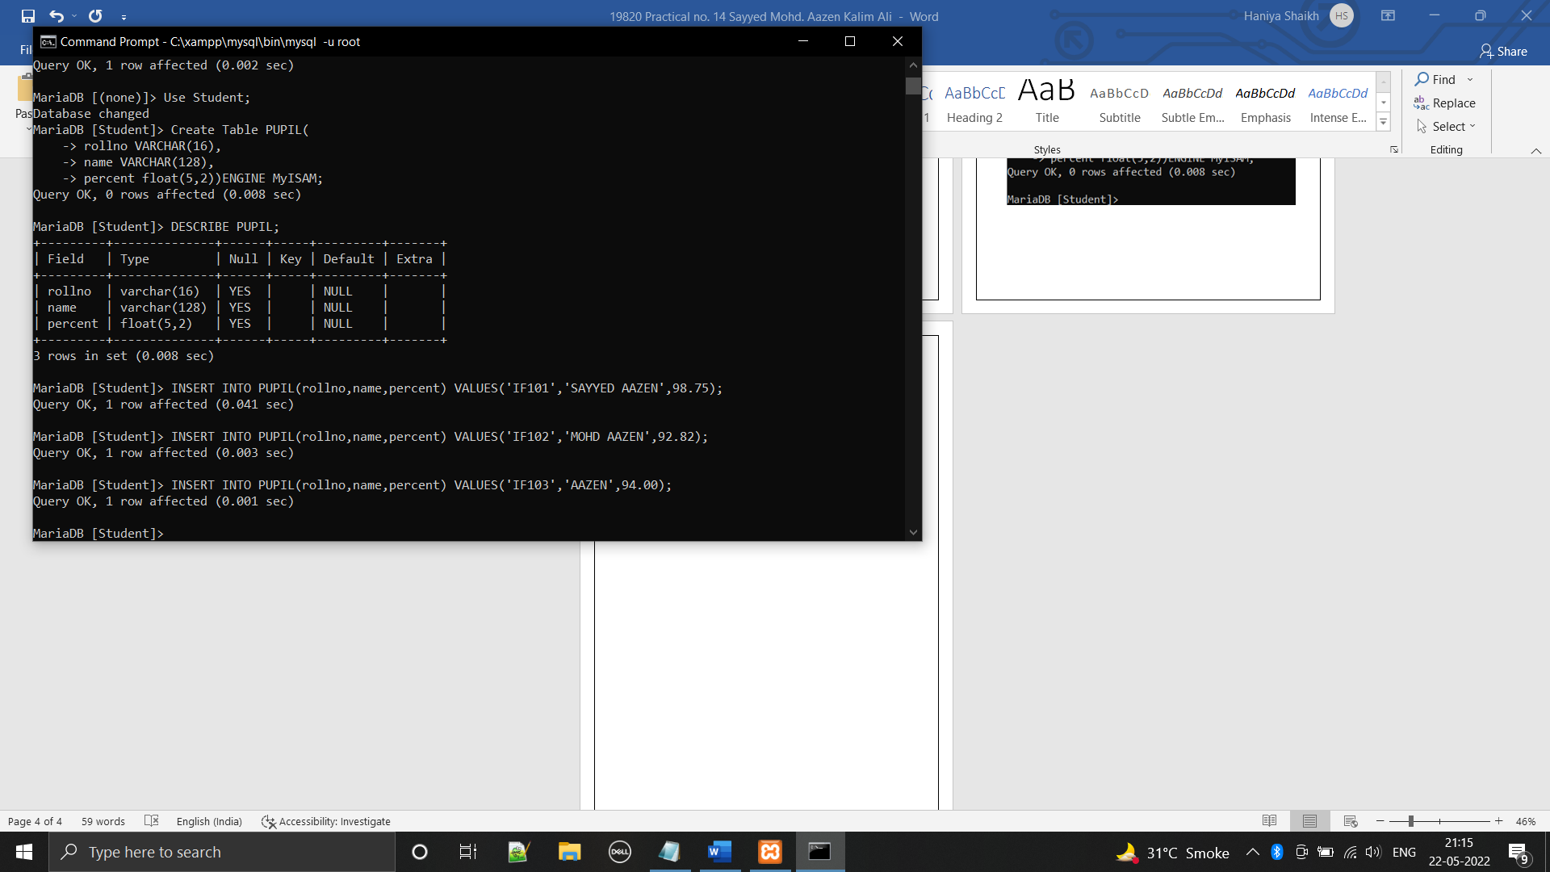 DELETING TABLE:**

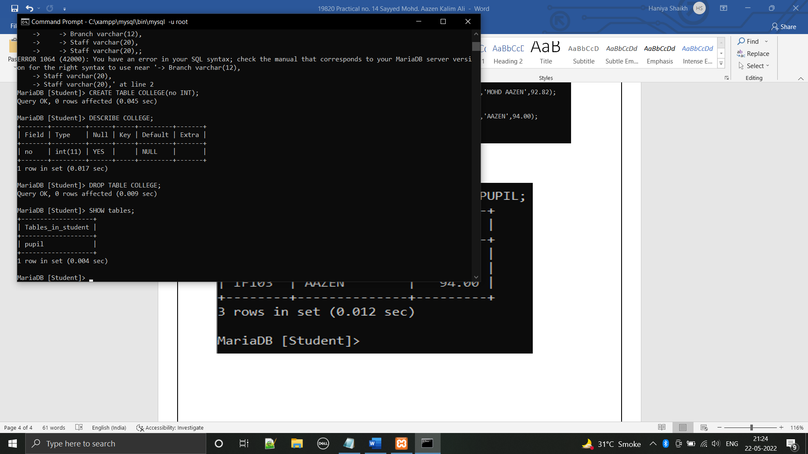

**QUERYING a MySQL DATABASE:  
SELECT COMMAND:**

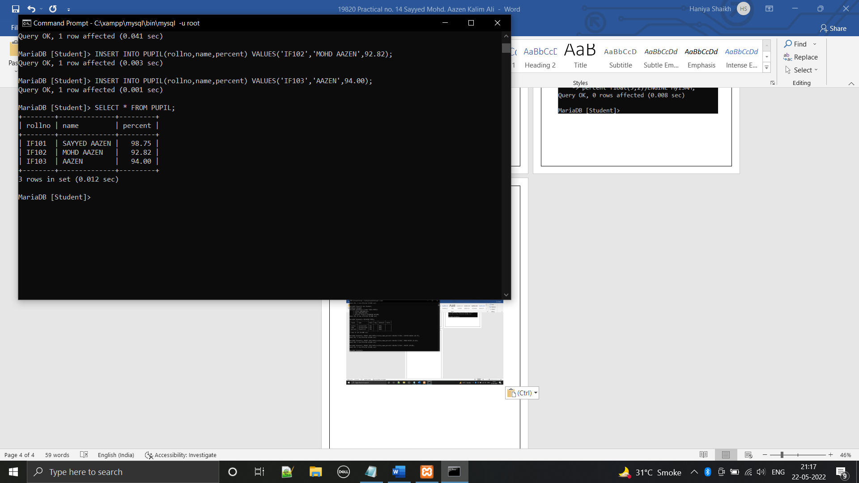 **DELETING ROW FROM TABLE :  
BEFORE:**

 **AFTER:**

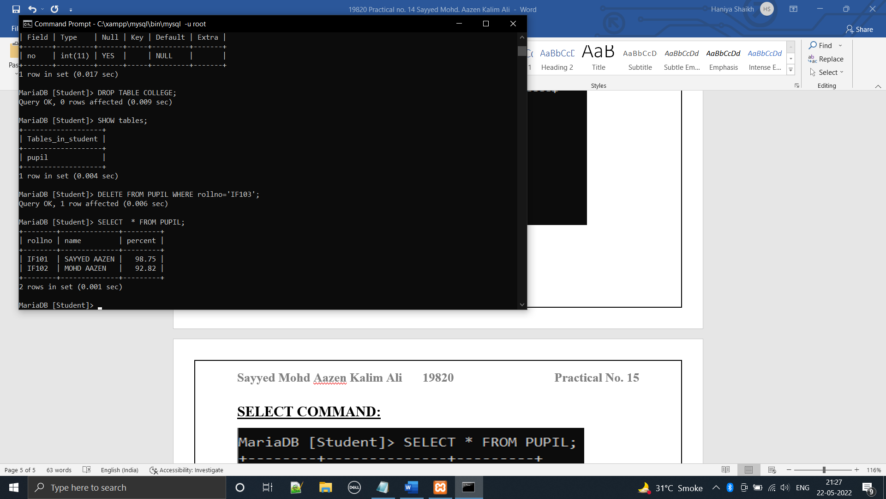

**WHERE COMMAND:**

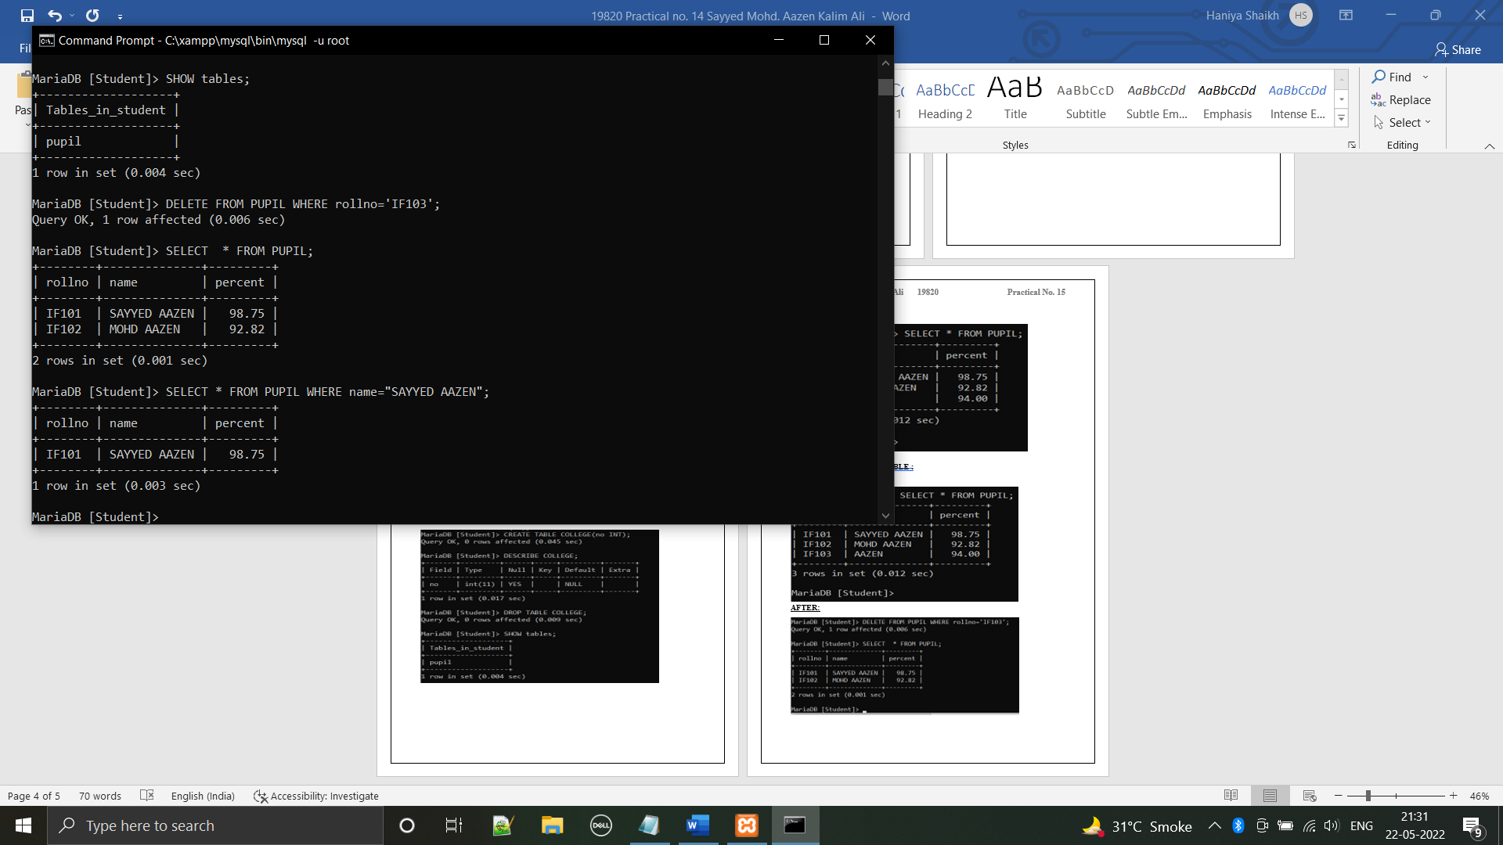

**CONNECTING TO MySQL:**

**CODE:***<?php*

*$hn="localhost";*

*$db="WBP";*

*$un="root";*

*$pw="";*

*$conn=new mysqli($hn,$un,$pw,$db);*

*if($conn->connect_error)die($conn->connect_error);*

*$query="INSERT INTO PHP (Name,Age)Values('Vinayak',19)";*

*$result=$conn->query($query);*

*if(!$result)*

*{*

*die("Database access failed ".$conn->error);*

*}*

*else*

*{*

*echo "Success!";*

*}*

*?>*

**OUTPUT:**

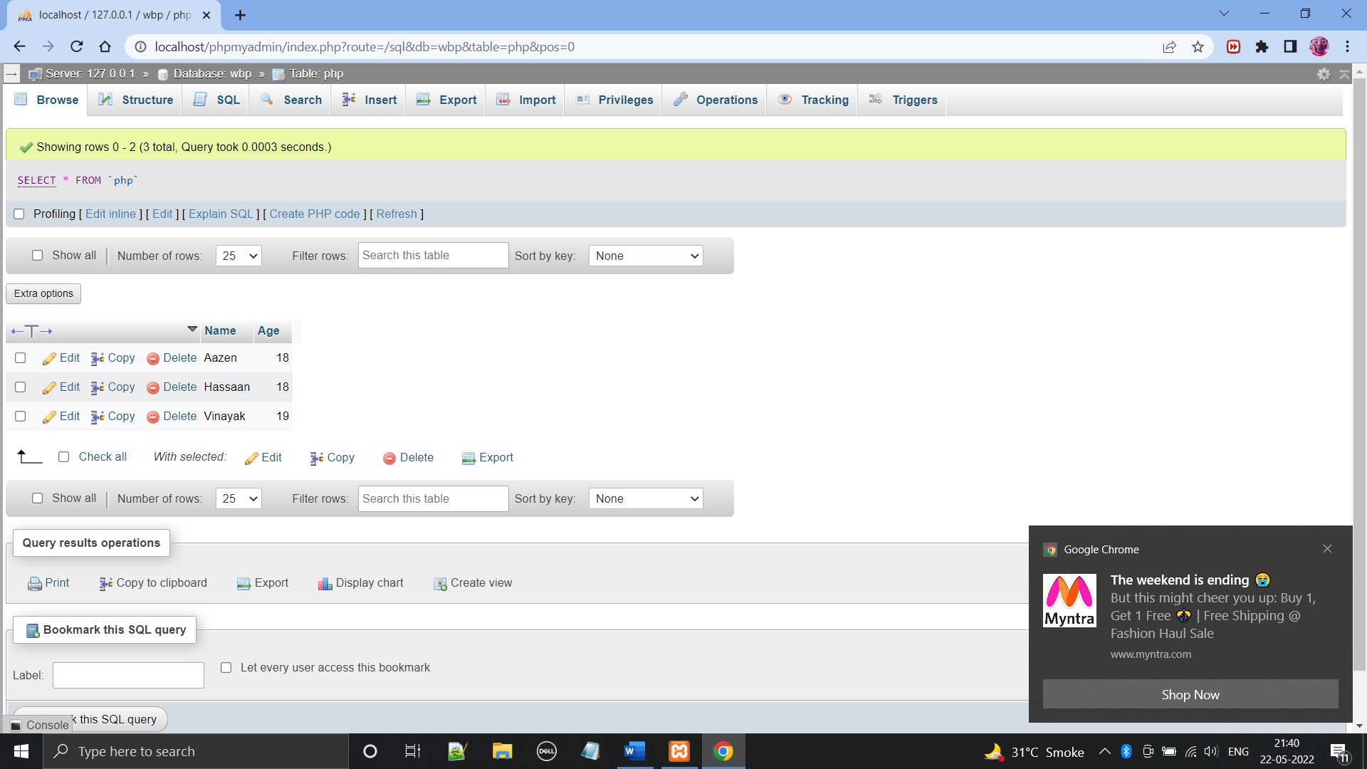

**CODE:**

*<?php*

*$hn="localhost";*

*$db="WBP";*

*$un="root";*

*$pw="";*

*$conn=new mysqli($hn,$un,$pw,$db);*

*if($conn->connect_error)die($conn->connect_error);*

*$query="SELECT * FROM PHP2";*

*$result=$conn->query($query);*

*if(!$result)die($conn->error);*

*$rows=$result->num_rows;*

*echo 'Connected';*

*for($j=0;$j<$rows;++$j)*

*{*

*$result->data_seek($j);*

*echo 'Roll No.:'.$result->fetch_assoc()['Roll_No.'].'</br>';*

*$result->data_seek($j);*

*echo 'Name:'.$result->fetch_assoc()['Name'].'</br>';*

*$result->data_seek($j);*

*echo 'Percentage:'.$result->fetch_assoc()['Percent'].'</br></br>';*

*}*

*$result->close();*

*$conn->close();*

*?>*

**OUTPUT:**

